**San Francisco Bay University**

**CS350 - Data Structures**

**Homework Assignment #7**

**Due day: 4/15/2023**

**Instructions:**

**a. Push the source code to GitHub**

**b. Please follow the code style rule like programs on handout.**

**c. Overdue homework submission can't be accepted.**

**d. Take academic honesty and integrity seriously (Zero Tolerance of Cheating & Plagiarism)**

1. Write a function/method to make all leaves in a binary tree tripled.
2. Define a function or write a method *Fib_tree(n)*in a class to create Fibonacci tree based on Fibonacci sequence, such as *0, 1, 1, 2, 3, 5, 8, 13, 21, 34, 55, 89, … …,* and *n* (starting from *1*)istermin the series.For instance, the following two trees will be generated when *Fib_tree(6)* and *Fib_tree(7)* are invoked.

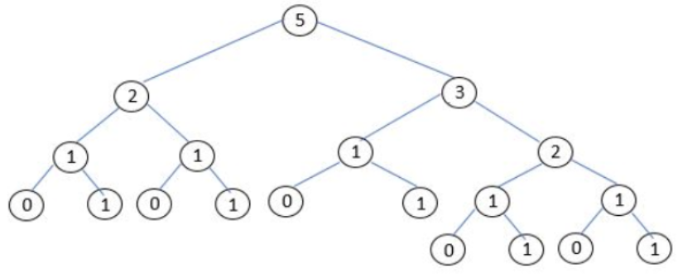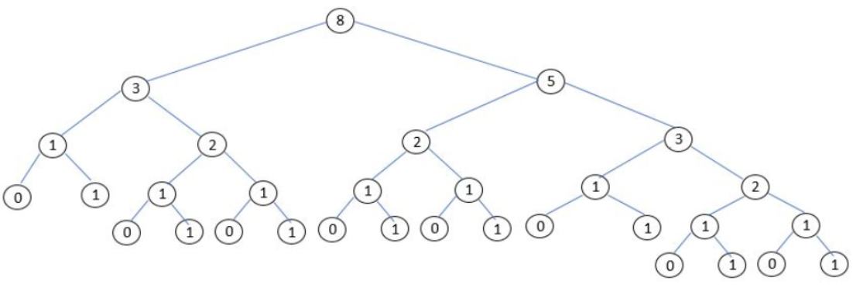

1. Implement a pruning function/method which takes in a binary tree ***t*** and a depth ***k***, and should return a new tree that is a copy of only the first ***k*** levels of ***t***. For example, if ***t*** is the tree shown as follows, then ***pruning(t, 3)*** should return the new tree

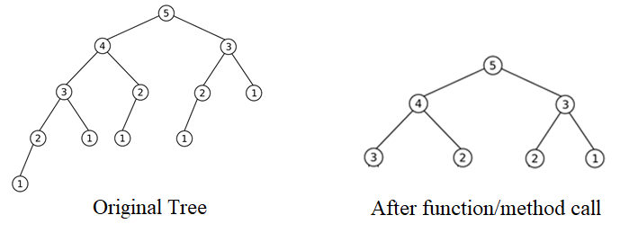

1. The arithmetic expression can be converted to a binary tree structure, where all leaves are numbers and all inner-node labels are operators (just considering *7* operations: +, -, *, /, //, %, **), such as the following binary tree for the expression: ***3 + ((5+9)*2).***Define a function/method ***eval(t)*** to calculate the expression value denoted by ***t***

